Tarih: 28.03.2025
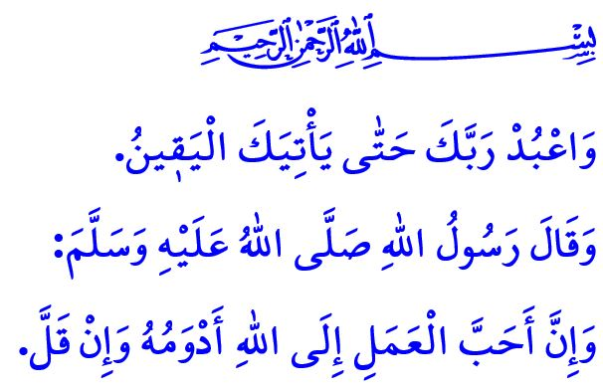
BIDDING FAREWELL TO RAMADAN
Honorable Muslims!
Another Ramadan is drawing to an end, passing from our lives once more. This evening, we will establish our final tarawih prayer, and tomorrow, we will observe our last fast, bidding farewell to this blessed season, inshallah. May Allah the Almighty make us among His blessed servants, those who find true life through the Qur’an, who are shielded from evil through prayer, who attain taqwa through fasting, and who purify their wealth and souls through zakat, sadaqah, and fitrah.
Dear Believers!
Ramadan is a school that returns each year to teach us how to live a life that is pleasing to Allah. In this distinguished school, we spent a month striving to learn how to be good individuals and sincere Muslims. We recited the Holy Qur’an, our ultimate guide to life. We endeavored to understand its messages and embody them in our lives. After Ramadan, too, let us strive to maintain this strong bond with the Holy Qur’an in every aspect of our lives. Let us continue to carry its blessings with us and integrate them into our daily lives.
Ramadan brought us together as families in our mosques for an entire month. In addition to our five daily prayers, we stood shoulder to shoulder in reverence during the tarawih prayers we performed. We soothed our hearts with supplications and salawats. However, our servitude is not limited to a day or a month. Our Almighty Lord invites us to a lifetime of servitude: “And worship your Lord until the inevitable comes your way.” Our Prophet (saw), moreover, reminds us that we should carry our worship into every moment of our lives, saying, “The most beloved of deeds in the sight of Allah are those that are continuous, even if they are small.” Let us, therefore, continue the worship habits we have cultivated during Ramadan throughout the entire year. Let us continue to attend the mosques and perform congregational prayers as a family, teaching our children the proper etiquette of the mosque.
Esteemed Muslims!
In the school of Ramadan, we strengthened our willpower through fasting and learned the virtues of patience. By stating, يَٓا اَيُّهَا الَّذ۪ينَ اٰمَنُوا اسْتَع۪ينُوا بِالصَّبْرِ وَالصَّلٰوةِۜ اِنَّ اللّٰهَ مَعَ الصَّابِر۪ينَ “O believers! Seek comfort in patience and prayer. Allah is truly with those who are patient.”, our Lord invites us to be patient and to seek His help through prayer and patience. Let us, therefore, make a conscious effort to reflect the patience we practiced during Ramadan in our home, school, work, marketplace, and even in traffic. Let us act with common sense and wisdom, rather than with hatred and resentment. Let us not break hearts; let us not hurt feelings.
Dear Believers!
Alhamdulillah, during Ramadan, the month of goodness, we embraced the motto of our Prophet (saw), كُلُّ مَعْرُوفٍ صَدَقَةٌ “Every good deed is sadaqah.” We have striven to walk the path of goodness by showing love and affection to our parents, spouses, and children, upholding the rights of our relatives and neighbors, and touching the hearts of orphans and the less fortunate. We gave our zakat and sadaqah to those in need, seeking the pleasure of Allah the Almighty. Moreover, with our material and spiritual resources, we have striven to be a source of hope in hearts and a smile on the faces of the oppressed worldwide, especially our brothers and sisters in Gaza, who endure the relentless bombardment of the Zionist occupiers. We have reaffirmed once again that we will never abandon them to the mercy of the oppressors. Let us, therefore, carry these fine qualities we have cultivated during Ramadan into every moment and every aspect of our lives. Let us continue to be righteous individuals, to spread goodness across the earth, to always stand against the oppressor, and to support the oppressed. Let us never forget that goodness holds a transformative power and that the world can only be changed through acts of kindness and righteousness.
Dear Muslims!
As I conclude this Friday’s khutbah, I would like to remind you of an important point. Starting today, many of us will embark on journeys to celebrate Eid al-Fitr with our loved ones, especially our parents, relatives, and friends. I call upon drivers, and especially our motorcycle-riders whose numbers have rapidly increased in recent years, to be patient, considerate, and attentive in traffic so as not to cast a shadow of sorrow over days of joy. Let us show respect for one another’s rights and uphold justice in all circumstances.

I would like to take this opportunity to extend my heartfelt congratulations to you on the upcoming Eid al-Fitr, which we will celebrate this Sunday. I pray to our Lord Almighty that all our Muslim brothers and sisters suffering under oppression, especially in Gaza, may soon regain their freedom.

Hijr, 15/99.
Abu Dawud, Tatawwu’, 27.
Baqarah, 2/153.
Bukhari, Adab, 33. General Directorate of Religious Services

